Recruitment Analysis – Key Findings & Recommendations
(January 2025 – September 2025)

Prepared by: Mohammed Sinan
Date: 4 / 2 / 2026

Project Overview
This report studies the stages in the hiring process, by examining metrics such as number of applications received, percentage hired, percent drop-off, department efficiency, source effectiveness and average time to move through each stage.
The objective is to identify:
- Measure funnel efficiency
- Identify bottlenecks or drop-off points
- Provide actionable recommendations
Key Metrics Summery:
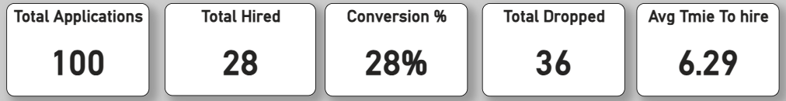
The recruitment process received a total of 100 applications, out of which 28 candidates were successfully hired, resulting in an overall conversion rate of 28%. During the process, 36 candidates dropped off at various stages. On average, it took approximately 6.29 days to complete the hiring process for selected candidates.
Recruitment Funnel Analysis:
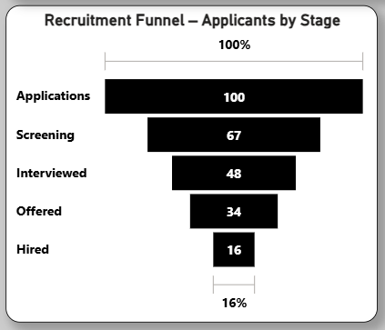
- Major drop-offs occur during the Screening stage.
- Only 16% of total applicants reach final hiring stage.
This indicates a strong filtering process early in the recruitment pipeline.
Department Performance Analysis :
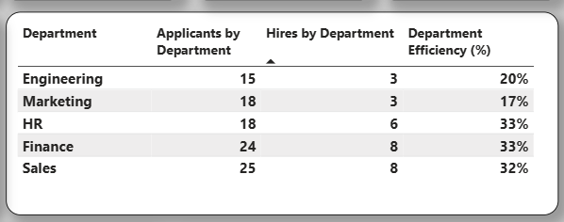
- HR and Finance show the highest efficiency.
- Marketing has the lowest hiring efficiency.
- Engineering also shows lower conversion compared to other departments.

Applicants and Hired by Department:
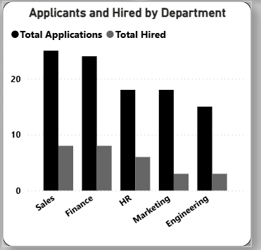
- Sales and Finance received the highest number of applications.
- Finance and HR show the strongest hiring efficiency (33%).
- Marketing has relatively low hiring efficiency (17%).
- Engineering has moderate applications but lower hiring conversion (20%).
Finance and HR are converting candidates more effectively, while Marketing and Engineering may need process improvements to improve hiring success.

Average Time Spent in Each Recruitment Stage (Days):
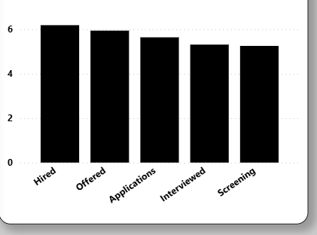
- The longest time is spent in the Hired and Offered stages (around 6 days).
- Screening and Interview stages take slightly less time (around 5–5.5 days).
- Overall stage timing is relatively consistent across all stages.
There is no extreme delay in one stage, but final decision-making (Offer → Hire) may slightly slow down the process.
Monthly Trend of Applications and Hires: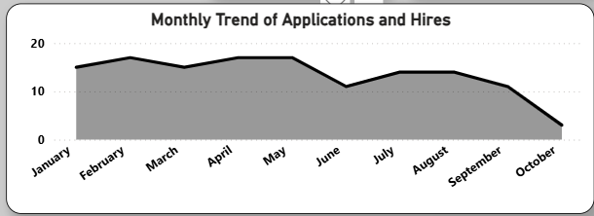
- Applications were stable from January to May.
- A noticeable drop occurred in June.
- Slight recovery in July and August.
- Significant decline in September and October.
Recruitment demand decreased toward the end of the period. This may be due to seasonal hiring patterns or reduced job openings.
Hiring Source Effectiveness:
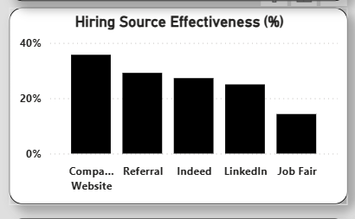
- Company Website generates the highest quality candidates.
- Job Fairs show the lowest effectiveness.

Drop-off Analysis:
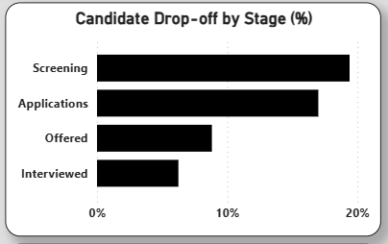
- Highest drop-off occurs at Screening stage.
- Offer stage also shows noticeable candidate decline.
Stage wise Conversion Rate %:
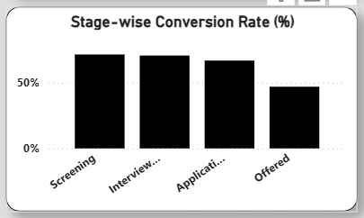
- High conversion rates in screening and interview stages indicate effective candidate filtering.
- Conversion drops at the offer stage, suggesting challenges in offer acceptance or decision delays.
- Improving offer competitiveness and response time can increase final hiring numbers

Recruitment Funnel Decomposition Analysis:
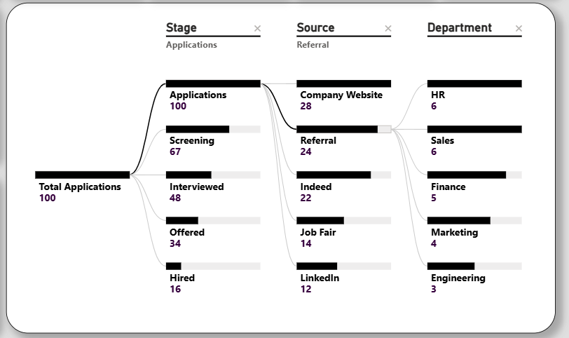
- The majority of applicants enter through the Company Website and Referrals, making them the strongest sourcing channels.
- Significant drop-offs are observed as candidates move from Interviewed to Hired, indicating a key decision-stage bottleneck.
- HR and Sales departments receive the highest number of candidates from top sources.
- Lower contribution from Engineering and Marketing suggests potential sourcing or role-specific challenges.

RECOMMENTATION:
- Concentrate on offer conversion and acceptance, it is the place for most candidate fall out.

- Double down and spend more on top performing sources like Company Website & Referrals in order to drive more quality candidates.

- Shorten the elapsed time between interview and offer to enhance candidates’ level of interest and offer-acceptance rates.
- Optimize recruiting efforts across underperforming departments (e.g., Engg and Marketing) to achieve better sourcing quality and hiring efficiency.

- Regular data-driven monitoring of stage conversion and drop-off rates is imperative to constantly improve the recruiting process.
CONCLUSION:
The recruitment funnel shows solid applicant flow, with an overall 28% yield, but there is room to enhance final-stage hires with less drop-off and better offer-acceptance rates. Strong sources (company website and referrals) which drive LP hiring success. Overall recruitment performance can be improved by maximizing stage efficiency and the exploitation of data-driven decision-making.

